**NAAN MUDALVAN ASSIGNMENT**

**NAME:** GAYATHRI D

**DEPARTMENT**: BE ELECTRICAL AND ELECTRONICS ENGINEERING

**COLLEGE**: 8110 IMAYAM COLLEGE OF ENGINEERING

**NAANMUDHALVAN COURSE**: DIGITAL MARKETING

**NM ID**: 1DA4DA32377BD8185414DAABFA856418

ASSIGNMENT 1:

Create a blog or website using Blogspot and word press. Customize the theme design and post new article with 500 words.

URL: <https://superlife17.blogspot.com/2023/10/welcome-to-superlife-organic.html>

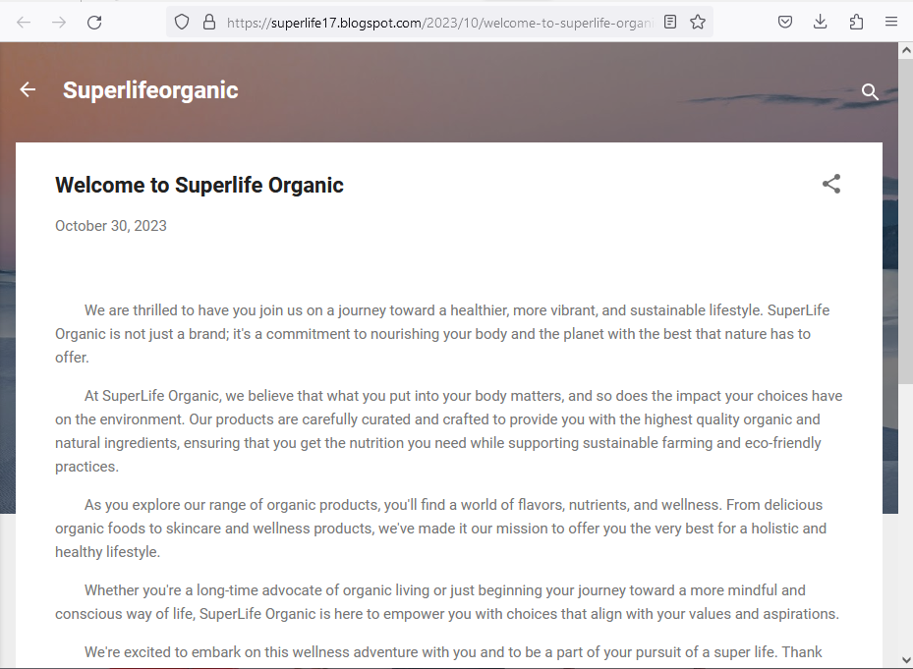

ASSIGNMENT 2:

Create a new Facebook business page and post one social media poster for your brand.

URL: <https://www.facebook.com/profile.php?id=61552223927318&mibextid=ZbWKwL>

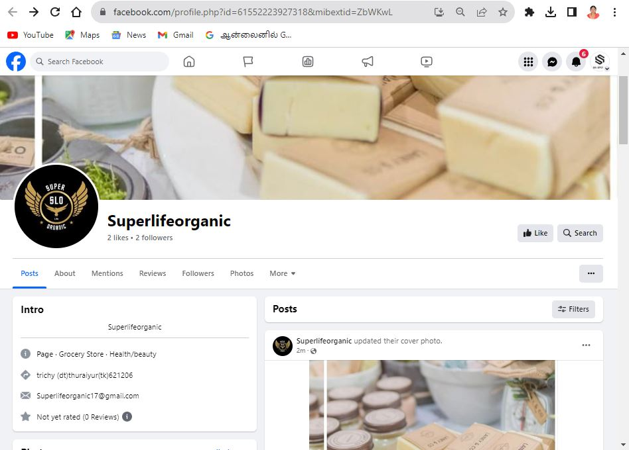

ASSIGNMENT 3:

Create and design a advertisement poster using Canva.

URL: <https://m.facebook.com/story.php?story_fbid=pfbid02NBCk6QEoUj9ZiwCweVnVcXXce9jKZkyQxg7jgVkVJX3FSuLiny9ND2WLEpjJbzRHl&id=61552223927318&mibextid=Nif5oz>

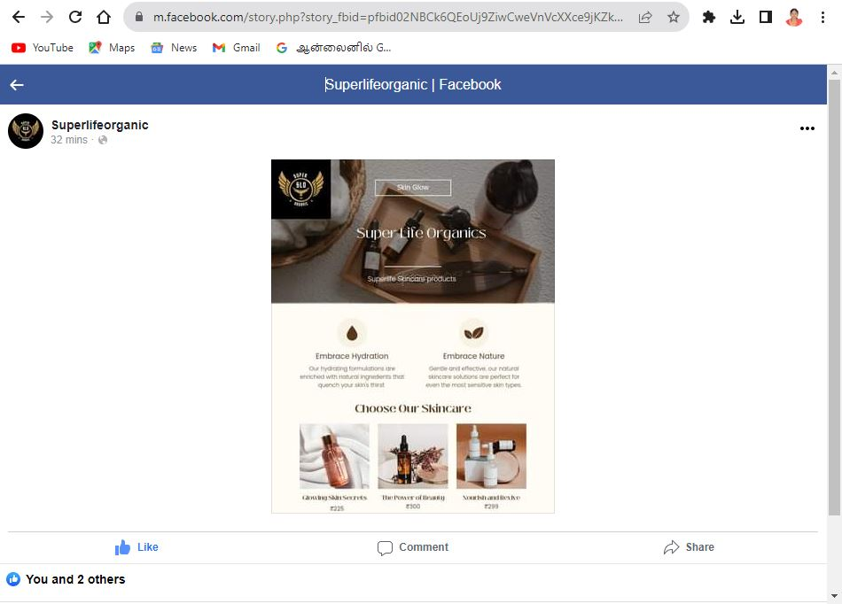

ASSIGNMENT 4:

Create an E mail newsletter design using Mailchimp or Canva tool.

URL: <https://superlife17.blogspot.com/2023/10/superlifeorganic-email-newsletter.html>

